

CONCEPT PAPER
on
Guarden: AI-Powered Pest Monitoring & Control

Francine Avielle E. Sayson
Rinan Geo M. Sundiang
Haygies Jessica G. Suñga
Bachelor of Science in Computer Engineering
School of Engineering and Architecture
Holy Angel University

March 03, 2026

Background of the Study
In today’s world, food security remains a critical challenge due to growing population and persistent food price inflation. According to Unicef (2025), an estimation of 673 million people faced hunger in the year 2024 in connection with the Sustainable Development Goal (SDG) 2. Another is a 40% approximation of agricultural crops lost annually due to pests and diseases. One strategy that emerged is home gardening in which it can supplement food for the family, lessen the grocery costs, and ensure access to fresh produce. Despite being a strategy, home gardeners lack expertise, time, and resources to monitor their plants regularly in maintaining healthy crops. Noticeable damage like wilted leaves, having holes, or even poor growth indicate that the crops are already being infested. Thus, delayed response leads to crop losses. Having a reactive pest control approach like the overuse or misapplication of pesticide may also pose risk to the crop quality and even to the human health and environment. These are highly intensive, chemically reactive practices that are mostly common in small backyard environments where professional advice is not readily available.
In the Philippine context, backyard gardening is tied in Filipino culture and economics in which many families grow crops like eggplant, tomato, bottle gourd (upo), pechay, and ladyfinger (okra) in small spaces. The tropical climate allows the plants to grow, yet it is also a favorable condition for the pests to multiply such as aphids, whiteflies, fruit borers, and leaf miners (Javier & Rodriguez, 2018). Most home gardeners rely on manual inspection and traditional pest control methods, which are time-consuming, inconsistent, and dependent on personal experience. Moreover, today’s existing automated pest management technologies are built for large commercial farms and not for home uses.
From a computer engineering perspective, the lack of availability of affordable, smart, and automated pest monitoring solutions aligned for small-scale household gardens exists. It limits the ability of home gardeners to detect pest threats early and respond effectively before serious crop damage occurs. Presently, the development of artificial intelligence (AI) and computer vision has created new opportunities in the form of earlier, more accurate and less chemically intensive pest management. Image recognition systems based on AI can be used to analyze images of crops and identify the presence of pests before they cause any damage that can be easily seen and then take appropriate action. Such systems transform pest management into a proactive model when combined with automated hardware that can be used to implement responses based on the results of detection. Guarden uses these technologies in the setting of a household garden, combining continuous AI-based scanning, pest verification, and automated spraying of organic neem oil to provide intelligent pest monitoring and control in a small, accessible system.
Literature Review
Pest infestations are among the most persistent threats to agricultural productivity, and the limitations of traditional management methods have become increasingly apparent. Traditional methods of crop protection have relied on the use of chemical inputs in large scale application, this poses a risk to biodiversity, human health and environmental sustainability. Javed et al. (2025) found that AI fundamentally alters this dynamic by providing the ability to identify threats accurately and early enough to allow growers to respond before the infestations get out of control and push agriculture toward more sustainable results. Balaska et al. (2023) investigated the effect of AI detection combined with automated intervention hardware directly by reviewing the integration of robotics and AI in crop protection systems and discovered that the combination of the two allows a fundamentally different method of pest control: one that does not treat the entire growing area with chemical treatment but only the infected plants. The paper has concluded that AI-controlled robotic systems are not merely more efficient forms of the old approaches but a change in the logic of pest control itself, a change in coverage-based intervention to confirmation-based intervention.
With regards to the choice of pesticide which is neem oil, Adusei and Azupio (2022) performed a systematic review of neem as a biocide to control pests and diseases in plants, summarizing the evidence on its effectiveness, chemistry, and safety profile in agricultural practices. The review established that neem-based pesticides do not leave any residual effect on agricultural produce and therefore are suitable to be used in household food gardens where the crops are consumed directly. It was demonstrated that the active compound azadirachtin could control more than 400 insect pest species, including the pests that pose the greatest threat to the vegetables that Guarden monitors, repelling them, preventing feeding, and interfering with their growth and reproduction. The research also established that neem preparations are useful in combating fungal pathogens, extending neem’s effectiveness beyond just insect pests.
In addition to confirming the use of AI detection as a general agricultural tool, studies have also covered the crops that Guarden is focused on. Sun et al. (2025) designed a detection model to detect pests and diseases in eggplants in complex field conditions. The paper has established that monitoring of eggplant requires detection methods that are specifically sensitive to the visual difficulties of the crop, including shadows, leaf cover, and uneven lighting, and automated AI monitoring is not only useful but essential to a crop where manual inspection routinely fails to detect damage at an early stage. Next, Nuhash et al. (2025) created an AI to classify diseases with a 99.52% accuracy rate with the final model being a web application that offers real-time diagnosis and treatment advice. Although the paper is restricted to diseases and does not discuss pest detection of bottle gourd in particular, it confirms that high-accuracy automated image-based classification is possible on the crop and can be implemented in practice. Additionally, Feroza et al. (2023) created a web-based application that uses AI to detect pests and diseases in pakcoy, the variety of Brassica rapa subsp. chinensis equivalent to the pechay grown in the Philippines. It had a test accuracy of 98% and provided early warning and treatment suggestions. Moreover, Hridoy et al. (2021) trained an AI on okra diseases and pests datasets, which allowed the AI to detect okra infections at an early stage, within four days of the first occurrence. The researchers noted that there was no known method of recognition of diseases and pests of okra before their study, even though the losses incurred were very high. The main results show that early-stage detection is not only technically feasible in the case of okra but directly causal, as it is the delay in the detection that enables the infestations to grow to cause serious losses of crops.
Lastly, the study that is the most directly applicable is an AI-based pest detection specifically in the Philippine setting and on crops that Guarden is capable of monitoring. Guiam et al. (2021) created SPIDTECH, an Android app that can be used to identify and monitor insect pests and diseases of nine major Philippine crops such as tomatoes remotely. The system was trained on local images and it was able to cover 71 insect pests and 63 diseases. By July 2021, it had more than 7,400 downloads and 5,600 registered users in 81 provinces, most of whom were farmers, which proved that there is actual, documented demand among Filipino growers to have access to AI-based pest identification tools. Brucal et al. (2023) also validated this need by creating a tomato leaf disease detector system designed to operate on Philippine conditions, where the tropical climate allows tomatoes to be grown all year round and at the same time maintain a continuous disease pressure. Their system identified 9 prevalent tomato leaf diseases and had an average precision of 99 percent, which confirmed that automated detection, even when applied to diseases, is reliable on tomato crops grown in the Philippines.
Among the studies reviewed, there is a gap. Research on AI detection and on automated intervention have been undertaken as mostly independent studies and few have integrated real-time AI detection and automated delivery of organic pesticides into one unit. Although it was confirmed that AI-based detection can be applied and is actively sought in the Philippine environment, none of the systems combines detection with any type of automated response. In other cases, it was determined that image-based classification can be done, but that ends at identification. Regarding the bottle gourd, the available literature only covers diseases, and pest detection in that crop is not fully addressed. None of the reviewed studies results in a system that unites detection and response in an automated form that can be owned and operated by a non-specialist, which is the gap that Guarden seeks to fill.
Existing studies determine the necessity of Guarden and the viability of its methodology. Javed et al. (2025) affirmed that AI-based systems, including Guarden, are more efficient options compared to traditional approaches that have many implications. Balaska et al. (2023) showed that AI detection with automated intervention changes pest control to a confirmation-based application, which directly confirms the reasoning behind the targeted neem oil delivery system of Guarden. Adusei and Azupio (2022) determined that neem oil is a safe, residue-free, and widely effective biopesticide against the insect pests and fungal pathogens that afflict the target vegetables of Guarden, which explains its selection. Sun et al. (2025) affirmed that real field monitoring of eggplant requires automated AI detection because it is challenging to detect the onset of pests by manual inspection. Nuhash et al. (2025) demonstrated that automated image-based detection can be performed and implemented on bottle gourd, but pest detection of the crop is an unaddressed gap in the literature. Feroza et al. (2023) showed that it is possible to classify pests in pechay with high accuracy and provide growers with actionable treatment advice. Hridoy et al. (2021) determined that automated recognition at an early stage is feasible and consequential to okra, a crop in which delayed recognition directly increases economic losses. The studies by Guiam et al. (2021) and Brucal et al. (2023) established the fact that AI-based pest detection is not only technically reliable but is also actively sought in the Philippine agricultural environment like in tomato. Guarden integrates all these elements of multi-crop pest detection and automated intervention into a single system to be used in household gardens in the Philippines.
Scope
Filipino home gardeners walk into their household gardens hoping that the crops are doing well, and only to realize that it may be too late, the pests have already invaded and the damage is now caused. Guarden seeks to transform that fact by creating an AI-driven pest management and detection system that introduces automated and surveillance to household gardening which is the livelihood of many Philippine households to provide fresh and affordable food. In this paper, the entire process of development and integration of three key aspects is discussed: a motorized rotating mount of the camera, constantly scanning five target crops (eggplant, tomato, bottle gourd, pechay, and okra), a convolutional neural network (CNN) trained on detecting and classifying visible pest infestations on regular camera images, and a solenoid-controlled neem oil dispensing system. Performance of the system shall be tested by the classification metrics of accuracy, precision, recall, and F1-score as well as real world hardware performance measures of rotation coverage consistency, spray targeting accuracy, and end-to-end system response time when used in the real world against the Philippine garden setting.
The system operates fully in the RGB imaging space, with the exclusion of multispectral and NIR imaging technology. These technologies are capable, but with hardware costs and complexity that are incompatible with the low cost and household-friendly vision of the core of this project. The study, instead of pursuing long-term crop yield data, which would require seasons of agricultural experimentation to establish, assesses the immediate measurable effect of the system, the reliability with which the system identifies pests, the accuracy with which it sprays, and the confidence with which an average home gardener can operate the system, in terms of usability, with non-technical users in structured usability testing on the System Usability Scale.
Significance of the Study
Guarden tackles the lack of automated, AI-based pest management systems in the crop garden of households. Its importance extends to the following domains:
- Household Food Production: Guarden allows home gardeners who lack formal training in agriculture to identify the threat of pests early and act before the crop is severely damaged, minimizing the loss of crops.
- Environmental Protection: The traditional household response to pests is usually the general use of chemicals irrespective of the level of infestation. The confirmation-based spraying mechanism of Guarden sprays neem oil only after AI confirms that there is an actual infestation, minimizing the amount of chemicals that are sprayed on the household environment in general.
- Human Health and Food Safety: Since Guarden uses neem oil, a biodegradable biopesticide that leaves minimal residual chemicals on the produce, it keeps the members of the household safer from chemical exposure during application and at the point of consumption. This renders pest management less hazardous to home gardeners, families, and to whoever consumes the harvested crops.
- Precision Agriculture Accessibility: Guarden introduces AI-based pest monitoring at a scale and budget accessible to households, which current precision agriculture technologies have not served. It reduces the entry cost of smart crop management to the common home gardeners.
- Academic Contribution: The paper presents a deployed reference on the combination of computer vision, IoT, and organic pest control in a domestic setting, which can serve as a basis of future studies on small-scale precision agriculture systems. It may inspire future researchers to further the study and work on innovations in the field of agriculture.
Conceptual Framework
At the core of Guarden development, an organized Input-Process-Output (IPO) model exists that reflects the very issue it is intended to address. The inputs to the system are based on three key sources: a continuous visual stream of RGB images of a rotating sprinkler-style camera mount scanning five target crops (eggplant, tomato, bottle gourd, pechay, and okra) in a Philippine tropical garden setting; a curated and augmented image training dataset of labeled pest and healthy crop images of the four common pest threats: aphids, whiteflies, fruit borers, and leaf miners; and user commands sent in real-time via the mobile application, such as manual spray override commands and system. These raw entry components are then processed through a five stage processing pipeline: the motorised camera completes a continuous low resolution rotation scan, an AI image recognition system gets the scan, stress results in binary stress flagging of each scanned frame, the motor freezes and zooms at any highlighted point on the plant to precision capture, a more complex AI classification system identifies multiple classes of pest with per-class confidence scoring and finally, a branching decision engine receives the identified infestation, which leads to either an early-stress alert without spraying or as a confirmed pest infestation which dispenses neem oil. The resulting products, namely automated delivery of organic pesticides to the verified only, real-time push notifications, and a plant health dashboard pushed to the mobile application, time-stamped activity and spray history, and a restoration of the rotation process to achieve near-real-time continuous monitoring, all operationalize the fundamental goal of the research which was to attempt early and automated pest detection in small-scale household gardens.
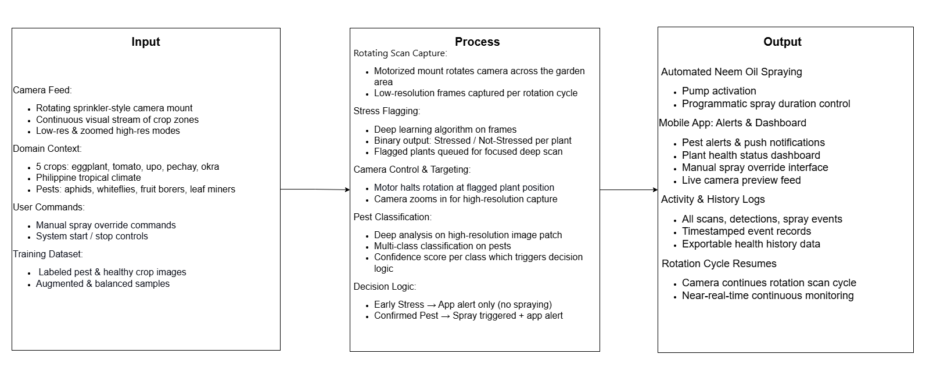
Statement of the Problem
The chief concern of this study is to develop and evaluate Guarden, an AI-powered pest monitoring and control that integrates rotating camera, AI-based plant stress and pest detection, and targeted organic pesticide, such as the neem oil, spraying to address the current challenges like late pest detection, lack of accessible pest monitoring, and control solutions for the household local crops. To find answers to the aforementioned concern, the researchers will seek answers to the following questions:
- How will the technology of Guarden be developed, including hardware components, AI algorithms, mobile application integration, and handling of prototype errors or calibration issues?
- How effective is Guarden in detecting the early plant stress, confirming pest infestations, and applying targeted neem oil spraying in a real household garden setting?
- What is the user’s feedback regarding the Guarden’s usability, reliability, and overall satisfaction?
Hypothesis
The study hypothesizes that the development of Guarden will result in an effective AI-powered pest monitoring and control system on the local crops like eggplant, tomato, bottle gourd, pechay, and okra in which it is capable of accurately detecting the early plant stress and confirming the pest infestations using the RGB imaging. In addition, it is expected that the integration of a rotating camera, AI-based classification model, and the neem oil spraying mechanism will achieve a high detection performance based on its accuracy, precision, recall, and the F1-score metrics. Also, it will provide real-time alerts and logs with the use of mobile application in order for the home gardener to be informed. It is expected to obtain positive user feedback in terms of its usability, reliability, and overall satisfaction. With this given innovation, it offers a practical and affordable solution to existing limitations in household pest monitoring and management.

Objectives
The proposed study is expected to develop and create an AI-driven pest management system that will provide the household gardeners within households in the Philippines with an automated mechanism of detecting pests in time and controlling the threat before severe damage to crops. Guarden combines a motorized rotating camera, a CNN-trained pest detector, a solenoid-controlled neem oil sprayer and a mobile application into a single integrated device making smart pest management accessible to the average Filipino home gardeners.
The specific objectives are:
- Gather and expand a labeled dataset of images of pest-infested and healthy crops to use to train a CNN-based model of pest classification on five crops of focus to achieve minimum accuracy of 85%.
- Create a functional hardware prototype to integrate a motorized rotating camera mount with a neem oil sprayer that can be controlled by a solenoid, into a deployable unit of a garden.
- Create a mobile application that will enable gardeners to be in control over activation and spray confirmation as well as informed in real-time pest notifications, plant health status screen, and logs of activities.
- Implement a decision engine that will automatically spray neem oil when pests are detected and send an early alert when initial signs of stress are detected.
- Test the entire system on CNN classification scores, hardware reaction, and spray precision scale and System Usability Scale testing with real home gardeners.
The proposed system design for this study employs a layered architecture block diagram and a system flowchart.
Block Diagram
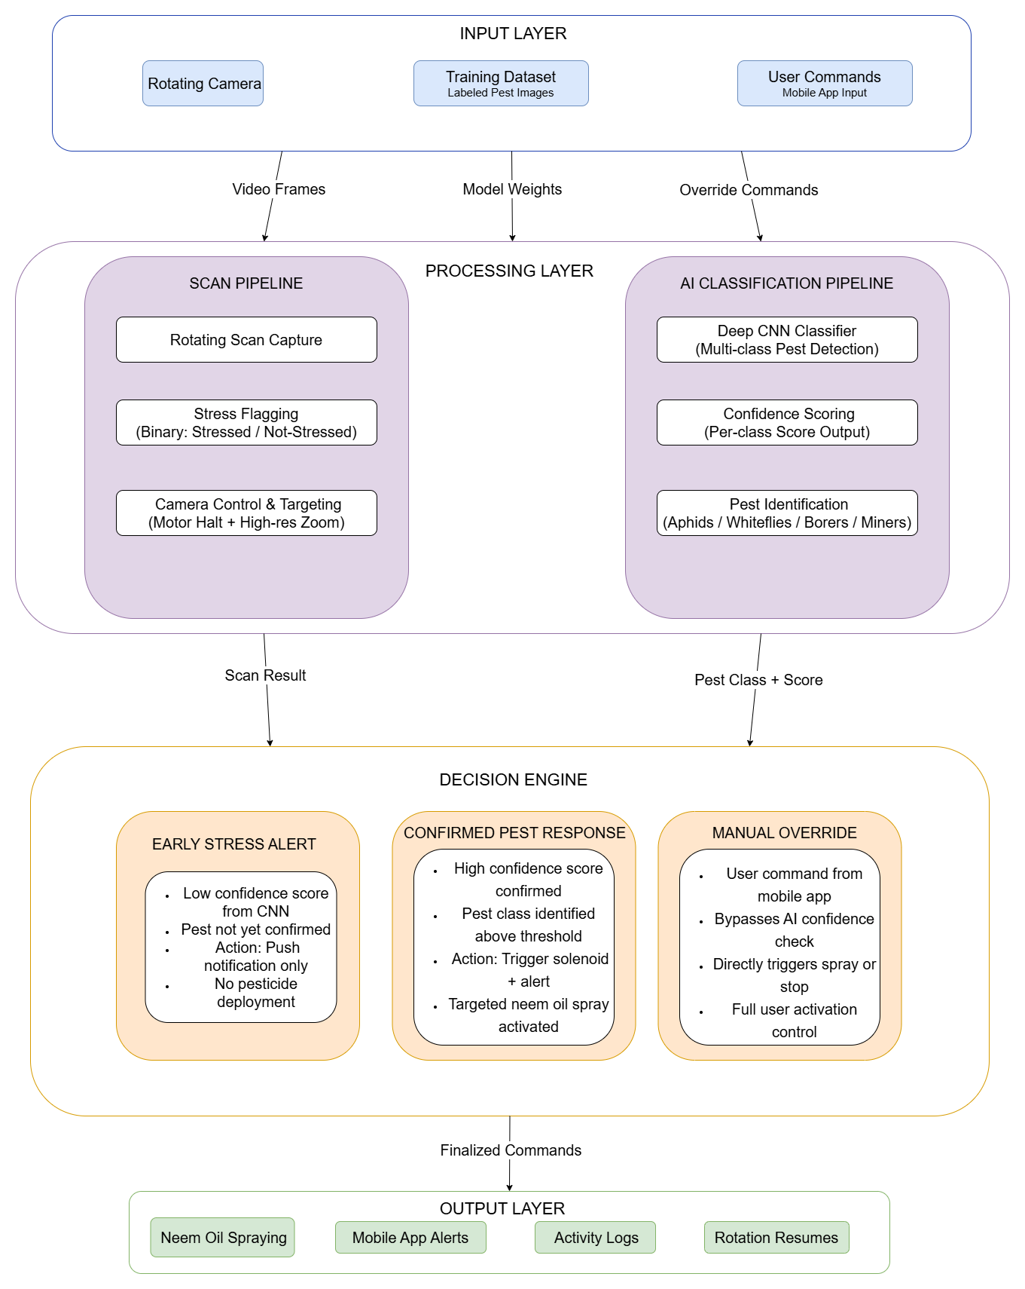

System Flowchart
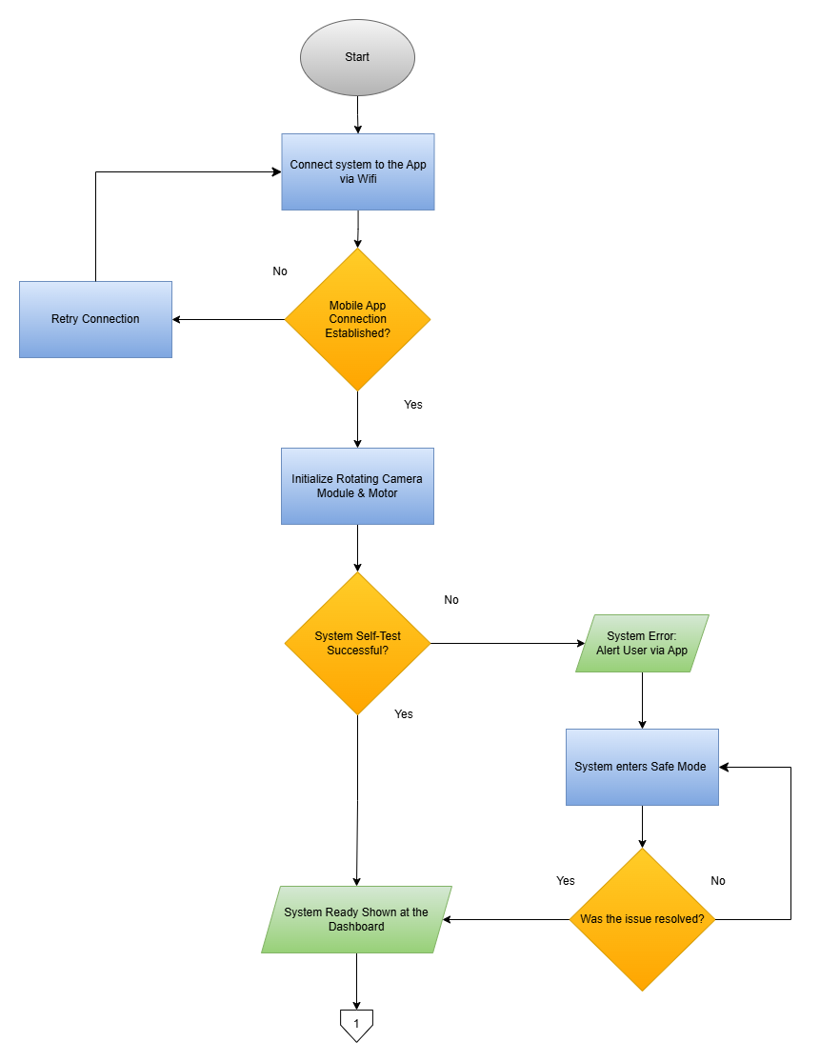
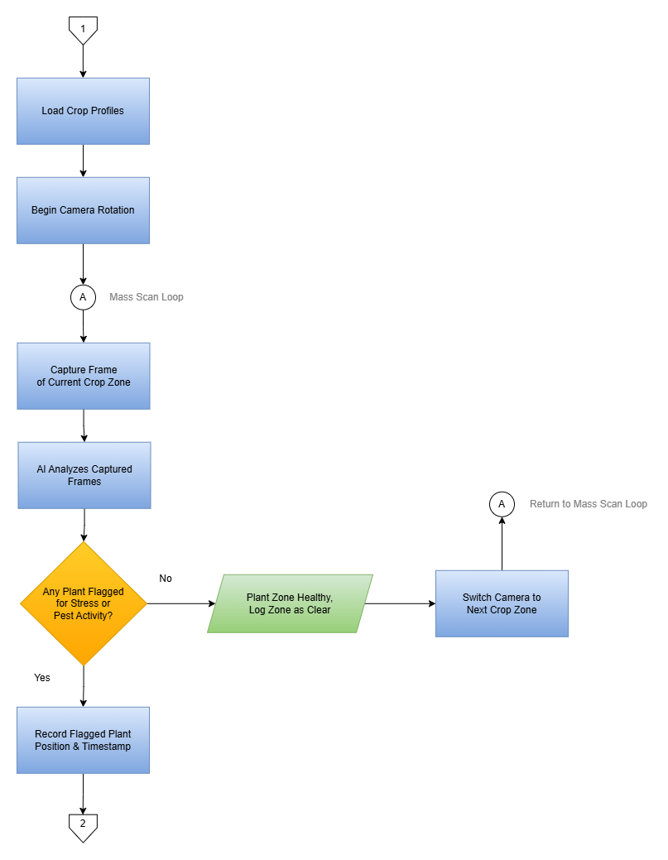

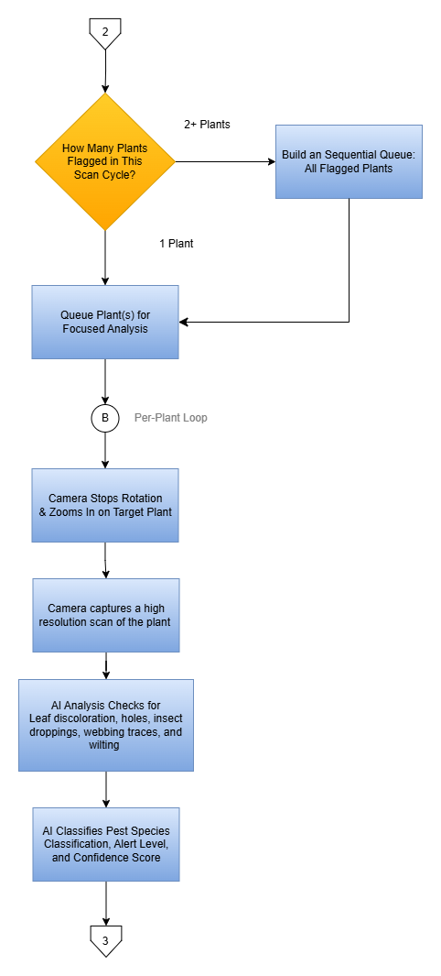
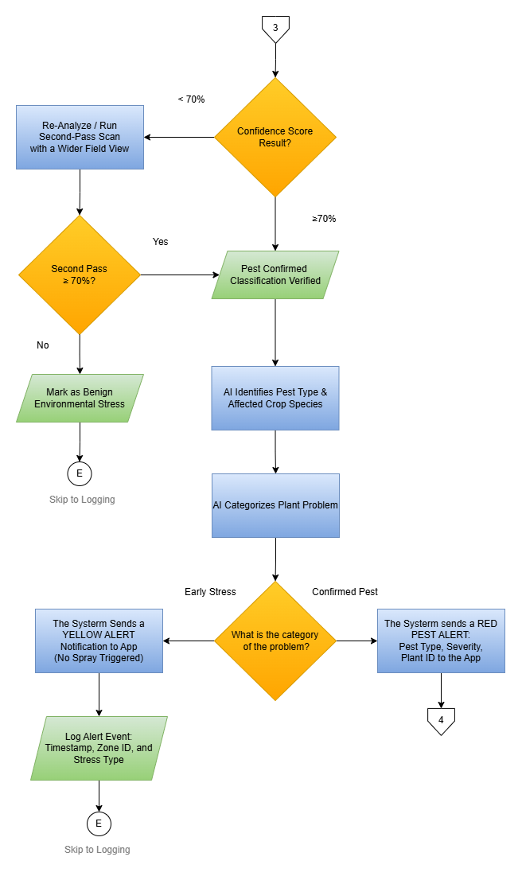
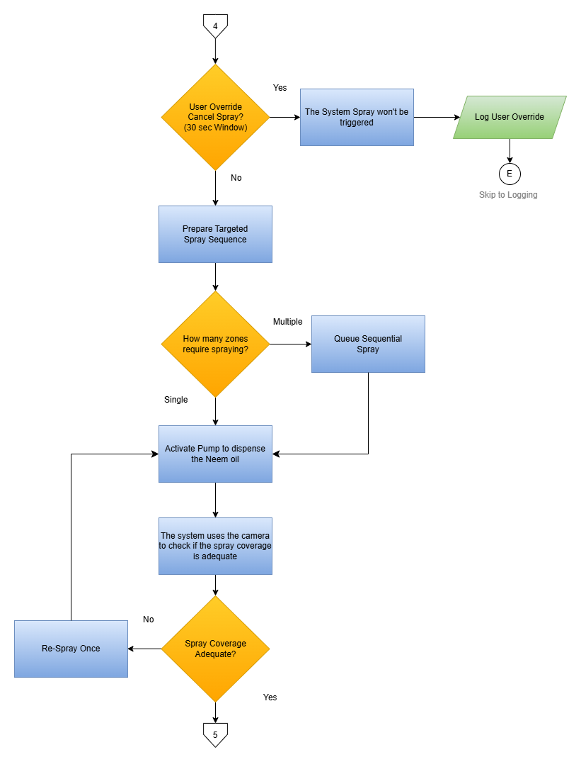
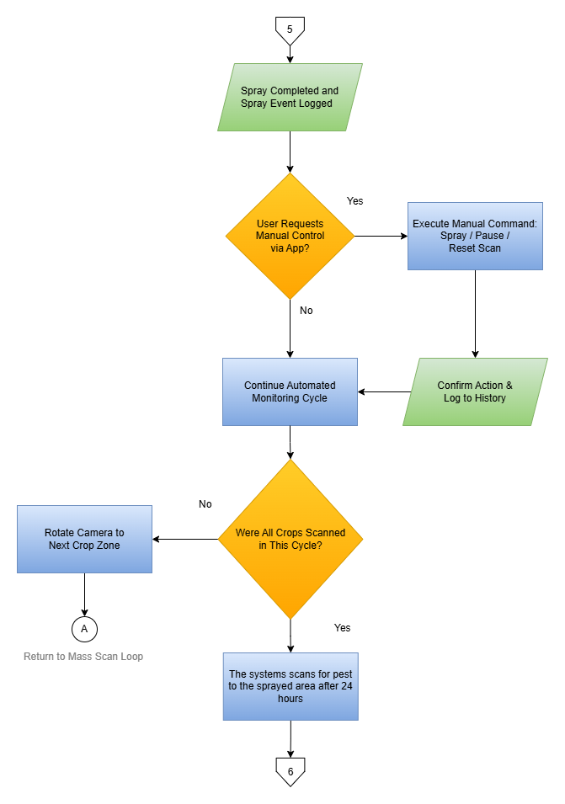
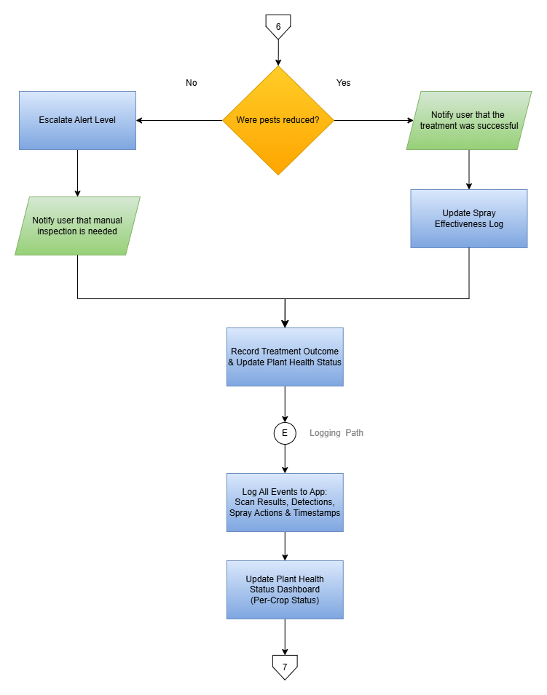
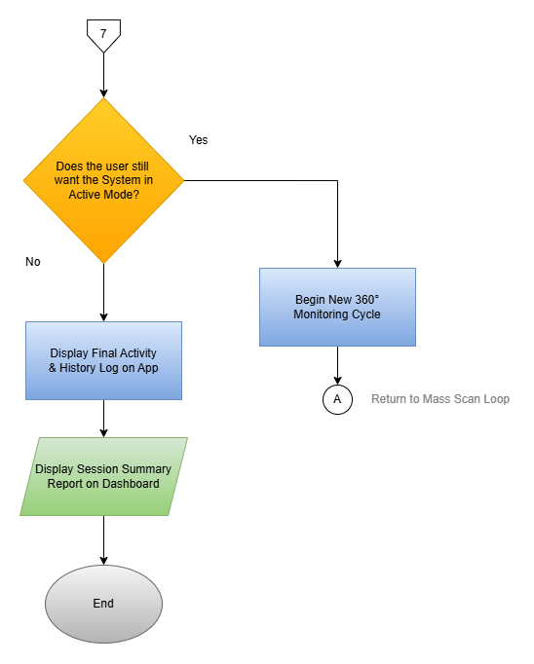
References
Adusei, K. A., & Azupio, D. (2022). Neem as a biocide for pest and disease control of plants: A systematic review. Journal of Biologically Active Products from Nature, 12(3), 180–207. https://doi.org/10.1155/2022/6778554
Balaska, V., Adamidou, Z., Vryzas, Z., & Gasteratos, A. (2023). Sustainable crop protection via robotics and artificial intelligence solutions. Machines, 11(8), Article 774. https://doi.org/10.3390/machines11080774
Brucal, S. G. E., de Jesus, L. C. M., Peruda, S. R., Samaniego, L. A., Jr., & Yong, E. D. (2023). Development of tomato leaf disease detection using YoloV8 model via RoboFlow 2.0. In 2023 IEEE 12th Global Conference on Consumer Electronics (GCCE) (pp. 692–694). IEEE. https://doi.org/10.1109/GCCE59613.2023.10315251
Feroza, N., Murti, D. M. P., Putro, N. A. S., Setiawan, H., & Hidayat, R. (2023). Development of a web-based application by employing a convolutional neural network (CNN) to identify pests and diseases on pakcoy (Brassica rapa subsp. chinensis). Pertanika Journal of Science and Technology, 31(6), 3091–3109. https://doi.org/10.47836/pjst.31.6.13
Guiam, A. C., Gutierrez, R. D., Gapasin, C. V. D., Matalog, R. P., & Ebuenga, M. D. (2021). Smarter Pest Identification Technology (SPIDTECH): A mobile application for digital identification and remote monitoring of insect pests and diseases of major crops in the Philippines. Philippine Journal of Science, 150(6B), 1811–1821. https://philjournalsci.dost.gov.ph/wp-content/uploads/2025/07/smarter_pest_identification_technology_.pdf
Hridoy, R. H., Afroz, M., & Ferdowsy, F. (2021). An early recognition approach for okra plant diseases and pests classification based on deep convolutional neural networks. In 2021 IEEE International Conference on Innovations in Science, Engineering and Technology (ICISET). IEEE. https://www.researchgate.net/publication/355126601
Javed, K., Smagghe, G., Wang, Q., Javed, H., & Wang, Y. (2025). Artificial intelligence in crop protection: Revolutionizing agriculture for a sustainable future. Information Processing in Agriculture. https://www.sciencedirect.com/science/article/pii/S221431732500085X
Javier, P., Phd, & Rodriguez, T. (2018, April 26). Managing Insect Pests in Organic Vegetable Production. Agriculture. https://agriculture.com.ph/2018/04/26/managing-insect-pests-in-organic-vegetable-production/
Nuhash, Md. M., Shekhor, S. A., Hoque, M. O., Khalid, M. I., & Bhuiyan, T. (2025). A deep ensemble learning and explainable AI framework for accurate bottle gourd disease diagnosis and deployment. Smart Agricultural Technology, 11, 100884. https://doi.org/10.1016/j.atech.2025.101541
Sun, X., Liu, Y., Gao, H., Shen, T., Liu, X., & Zhong, X. (2025). Research on eggplant pest and disease detection in complex environments based on improved RT-DETR. BMC Plant Biology, 25, 412. https://doi.org/10.1186/s12870-025-07518-2
Unicef. (2025, August 8). The State of Food Security and Nutrition in the World 2025. https://data.unicef.org/resources/sofi-2025/

